**Project Report**

# **Project Title:** WhatsUrSay.

# **Group Information:**

* 1. **Name:** DSEs
  2. **Members:**
     + Sreedevi Koppula
     + Rajashekhar
     + Nikhitha Kaza
     + Abhinav Bhandaram.

# **Project Description:**

* 1. **Description:**

“What’sUrSay?” is an online polling and survey system. This is a web application that is comprised of the following features:

1. A person signs up using registration form to become a user of the system.
2. A user can be granted any of the below three user roles based on the administrative position of the user and the requirement:
3. Admin (A)
4. Group leader (L)
5. Normal User (U)
6. Each user is provided with a dashboard.
7. The users can view their dashboard only upon their successful login

The appearance of dashboard and the features provided to a user vary from one user role to the other.

Below are the features provided to regular users (U) on their dashboard:

The dashboard contains the below details:

1. Filter to select ‘Polls’ or ‘Surveys’ or ‘Both’
2. Filter to select ‘Private’ or ‘Public’, this would filter the ‘Polls’ and ‘Surveys’ respectively.
3. Once the filters are selected by the user, one of the below actions take place:

* Upon the choice of ‘Polls’ and ‘Private’, the user will be listed all the Polls (already participated and non-participated), where the user is one among that poll group
* Upon the choice of ‘Polls’ and ‘Public’, the user will be listed all the Polls (already participated and non-participated), where the user is not one among that poll group
* Upon the choice of ‘Surveys’ and ‘Private’, the user will be listed all the Surveys (already participated and non-participated), where the user is one among that survey group
* Upon the choice of ‘Surveys’ and ‘Public’, the user will be listed all the Surveys (already participated and non-participated), where the user is not one among that survey group
* Upon the choice of ‘Both’ and ‘Private’, the user will be listed all the Polls and Surveys (already participated and non-participated), where the user is one among that poll or survey group
* Upon the choice of ‘Both’ and ‘Public’, the user will be listed all the Polls and Surveys (already participated and non-participated), where the user is not one among that poll or survey group

1. From the list of Polls or Surveys or Both displayed to the user, the user can do one of the below actions:

* Select a Poll or Survey and view its details such as date of creation, created by, description of the Poll or Survey, etc.
* Select a Poll or Survey that is still open for the user response and then participate in it
* Select a Poll or Survey that is already completed and view its results

1. After the participation of user in a Poll/Survey, a participation confirmation email will be sent to the user.
2. Once the evaluation of the Poll is completed, the corresponding group users receive the results in an email.
3. The user has the option to see the names of all groups and other details of the groups that he belongs to.
4. Option to view the ‘Request for Group Leadership’ form (If the user is planning to become a group leader, this form is to be completed and submitted to the admin)
5. Option to fill out the form and submit to the admin (If the admin approves this, then the role of user is changed from ‘U’ to ‘L’, and he gets all the privileges and options of group leader after his next successful login)
6. Settings for updating the user account details (User name, password, profile picture, ‘About’ details)
7. “Sign out” button

Below are the features provided to Group Leaders (L) on their dashboard:

1. Create a user group
2. Add a user to the group
3. Remove a user from the group
4. Move the group ownership to other person
5. Delete the group
6. Create a poll/survey
7. Edit or update poll/survey details (Details: Title of the poll/survey, description, scheduled dates, add another group to the poll/survey, etc.)
8. Delete poll/survey
9. Option to see the list of groups that are created by him/her.
10. Option to see the list of polls/surveys that are created by him/her.
11. Option to click on ‘Calculate Results’ of a poll and publish the results to the corresponding poll groups. (upon ‘publish’, an email will be sent to the users with the results details)
12. Filter to select ‘Polls’ or ‘Surveys’ or ‘Both’
13. Filter to select ‘Private’ or ‘Public’
14. Once the filters are selected by the user, one of the below actions take place:

* Upon the choice of ‘Polls’ and ‘Private’, the user will be listed all the Polls (already participated and non-participated), where the user is one among that poll group
* Upon the choice of ‘Polls’ and ‘Public’, the user will be listed all the Polls (already participated and non-participated), where the user is not one among that poll group
* Upon the choice of ‘Surveys’ and ‘Private’, the user will be listed all the Surveys (already participated and non-participated), where the user is one among that survey group
* Upon the choice of ‘Surveys’ and ‘Public’, the user will be listed all the Surveys (already participated and non-participated), where the user is not one among that survey group
* Upon the choice of ‘Both’ and ‘Private’, the user will be listed all the Polls and Surveys (already participated and non-participated), where the user is one among that poll or survey group
* Upon the choice of ‘Both’ and ‘Public’, the user will be listed all the Polls and Surveys (already participated and non-participated), where the user is not one among that poll or survey group

1. From the list of Polls or Surveys or Both displayed to the user, the user can do one of the below actions:

* Select a Poll or Survey and view its details such as date of creation, created by, description of the Poll or Survey, etc.
* Select a Poll or Survey that is still open for the user response and then participate in it.
* After the participation, the Poll or Survey link is disabled in order to avoid a person to participate twice or more number of times in the same poll or survey.
* Select a Poll or Survey that is already completed and view its results

1. After the participation of user in a Poll/Survey, a participation confirmation email will be sent to the user.
2. Once the evaluation of the Poll is completed, the corresponding group users receive the results in an email
3. The user has the option to see the names of all groups and other details of the groups he belongs to.
4. Settings for updating the user account details (User name, password, profile picture, ‘About’ details)
5. “Sign out” button

Below are the features provided to Admin (A) on his/her dashboard:

1. View the requests received for ‘Group Leadership’ from normal users (This request is sent to admin when the normal user fills and submits the ‘Request for Group Leadership’ form.
2. Review the requests and decide upon assigning or declining the group leadership to a person
3. Change user role of a person from normal user (U) to group leader (L) based upon successful verification of his background and position.
4. Create a group and assign a group leader to it
5. Remove the group (Admin is not given the privilege to add users to the group. Only a group leader can do add the users)
6. Option to see the list of groups that are created by him/her.
7. Move the admin ownership to other person
8. Filter to select ‘Polls’ or ‘Surveys’ or ‘Both’
9. Filter to select ‘Private’ or ‘Public’
10. Once the filters are selected by the user, one of the below actions takes place:

* Upon the choice of ‘Polls’ and ‘Private’, the user will be listed all the Polls (already participated and non-participated), where the user is one among that poll group
* Upon the choice of ‘Polls’ and ‘Public’, the user will be listed all the Polls (already participated and non-participated), where the user is not one among that poll group
* Upon the choice of ‘Surveys’ and ‘Private’, the user will be listed all the Surveys (already participated and non-participated), where the user is one among that survey group
* Upon the choice of ‘Surveys’ and ‘Public’, the user will be listed all the Surveys (already participated and non-participated), where the user is not one among that survey group
* Upon the choice of ‘Both’ and ‘Private’, the user will be listed all the Polls and Surveys (already participated and non-participated), where the user is one among that poll or survey group
* Upon the choice of ‘Both’ and ‘Public’, the user will be listed all the Polls and Surveys (already participated and non-participated), where the user is not one among that poll or survey group

1. From the list of Polls or Surveys or Both displayed to the user, the user can do one of the below actions:

* Select a Poll or Survey and view its details such as date of creation, created by, description of the Poll or Survey, etc.
* Select a Poll or Survey that is still open for the user response and then participate in it
* Select a Poll or Survey that is already completed and view its results

1. After the participation of user in a Poll/Survey, a participation confirmation email will be sent to the user.
2. Once the evaluation of the Poll is completed, the corresponding group users receive the results in an email
3. The user has the option to see the names of all groups and other details of the groups that he belongs to.
4. Settings for updating the user account details (User name, password, profile picture, ‘About’ details)
5. “Sign out” button.
   1. **Development Environment:**

* **OS:** Windows
* **Programming Language:** C#, TypeScript
* **Database:** MySql
* **UI and JavaScript Frameworks:** Bootstrap, Angular JS, HTML, CSS, JQuery
* **Server Side Technologies:** ASP.NET MVC Web API, ASP.NET Core

# **Meeting Minutes:**

**Team Members/ Attendees**:

* Abhinav Bhandaram (Team LEAD )
* Rajashekar Goud Korakoppula
* Sreedevi Koppula
* Kaza Nikhitha

1. **Meeting on:** 08/30/2016

**Location:** In class, B157

**Time:** 10:50 AM - 11:20 AM

**Topics discussed:**

1. Group Formation

2. Introduction to each other

3. Decision on the group leadership

4. Sharing thoughts and experiences on project development

5. Discussion on the type of application to be developed (Web Application or Android application or Windows application).

1. **Meeting on:** 08/31/2016

**Location:** Library, Discovery Park

**Time:** 4 pm-6 pm

**Topics discussed:**

1. Each person proposed a project idea

* Sreedevi: E-commerce application
* Rajashekhar: Library Management System
* Nikhitha: ERP for Universities
* Abhinav: Online Examination Portal, Online Polling/Voting application

1. Evaluation of the project ideas based on feasibility, complexity, time of availability, manual effort needed, etc. for project development.
2. **Meeting on:** 09/01/2016

**Team Name:** DSEs

**Location:**  Class, B157

**Time:** 10:50 AM – 11:20 AM

**Topics discussed:**

1. Finalized 2 topics out of 5, proposed by the team

2. discussed the purpose and overview of ‘Online Voting Application’ that was finalized as our group project

3. Discussed briefly the requirements and project schedule

1. **Meeting on:** 09/06/2016

**Location:** In class, B157

**Time:** 10:50 AM - 11:20 AM

**Topics discussed:**

1. Discussed the requirements
2. Discussed the technologies needed for project development
3. Proposed MVC architecture for the project development
4. Discussed the decomposition of project into modules
5. Identified the target audience
6. Defined the scope of the project
7. **Meeting on:** 09/08/2016

**Location:**  Willis Library

**Time:** 18:30-21:00

**Topics discussed:**

1. Risks involved in the project and their contingency plans

2. High level project plan, project timeline

3. GANTT and PERT charts parameters

1. **Meeting on:** 09/08/2016

**Location:**  Class, B157

**Time:** 10:50 AM – 11:20 AM

**Topics discussed:**

1. Project’s directory structure and low level details of it

2. Web pages UI layout

3. Low level requirements of the project.

# **Gantt and PERT Charts:**

* 1. **Gantt Chart**

Gantt chart is a best way to represent project’s status graphically. It is a kind of bar-chart which is used to schedule a project that helps us to plan, coordinate the tasks and track the specific tasks of the project. Below is the Gantt chart that explains our project schedule:

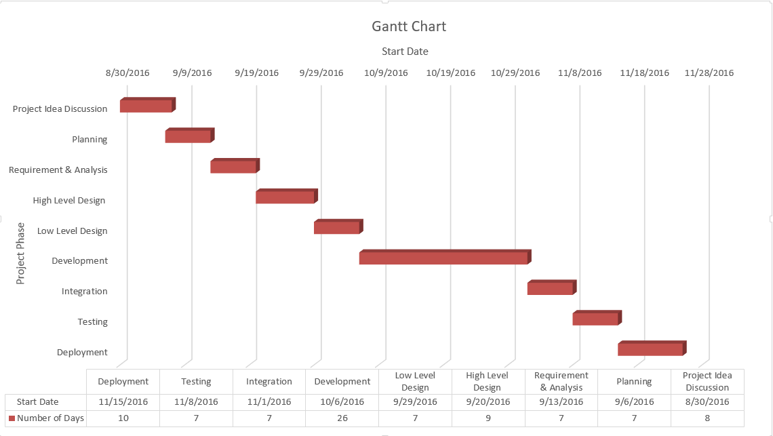

The attributes chosen for preparing the Gantt chart are: start date and project phase. The project phases of our project are: Project Idea Discussion, Planning, Requirement & Analysis, High Level Design, Low level Design, Development, Integration, Testing, and Deployment. From the above Gantt chart, it is clear that none of our project tasks are overlapping and all the tasks will be executed one after the other. The data table has start date and number of days for the completion of project as attributes.

* 1. **PERT Chart**

A pert chart is a graphical representation of the project as a network diagram that consists of nodes representing the events of the project which are linked by directional lines. The direction of the arrows on the lines indicates the sequence of the tasks.

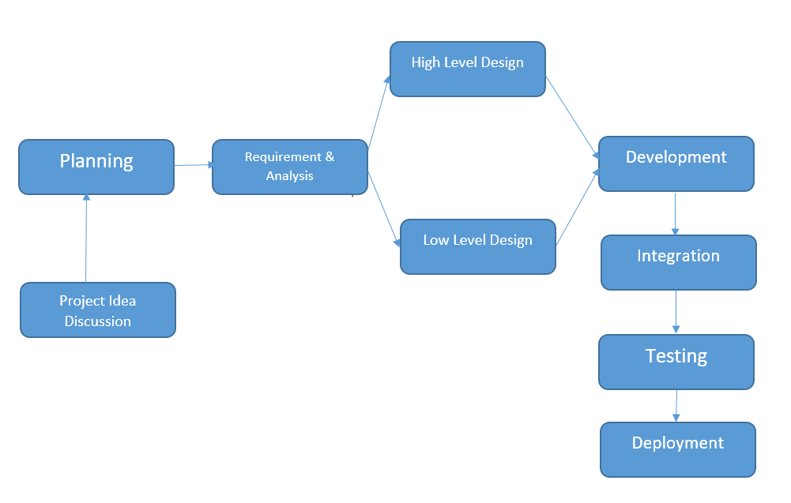

# **Risk Management Plan:**

|  |  |  |  |  |  |
| --- | --- | --- | --- | --- | --- |
| S.NO | Risks | Description | Monitoring | Contingency Plans | Reevaluation |
| 1 | Misunderstanding of requirements. | Each developer may understand requirement in different way. | Code developed by one developer is tested by another to verify the correctness of functionalities. | At each phase code is tested, if a developer misunderstood requirements and coded the same then recoding is done as per correct requirements while other developers share extra work. | Before starting to code any doubts on requirements are clarified with clients but still there are chances of this risk. As project progresses at end of each module development this risk is reevaluated by testing core functionality. |
| 2 | Missing deadlines. | There are many reasons for missing deadlines like less productive, environmental factors, medical leave and etc. | Percentage of work done is calculated to understand if it is with in timelines as per schedule | Reason is identified. If there is a medical emergency, then amount of work is shared among other developers. | Backup plan should be included in project plan. This risk is reevaluated weekly basis to check there are no deadline misses. |
| If a developer is less productive then training is given to cope up. |
| 3 | Lack of Technical Knowledge. | All team members may not have knowledge on all technologies used in the project | In every team meeting technologies to be implemented in current phase are discussed to understand if developers has enough knowledge to start work. | Training is given for required technologies. | This risk is reevaluated by discussing technical concepts among developers at start of new module. |
| 4 | Conflicts among developers. | Conflicts among developers may occur on approach. | Before starting to work on an activity or a module, opinion on approach to implement is taken from each developer. | Advantages and disadvantages of each approach is discussed and appropriate approach is selected. | This risk is reevaluated by testing implemented approach in terms of performance, extensibility and working. |
| 5 | Low quality. | Measured in number of defects. More number of defects infer low quality | Will keep track of number of defects found at end of each activity and analyze quality of code. | Code quality is checked at end of each week. Defects are classified and root causes for defects are analyzed and appropriate action is taken based on metrics. | This risk is reevaluated at the end of functionality testing of each module to take necessary actions to keep defects low in next module. |

# **Manager Report:**

Team Name: DSEs (The Software Engineers).

Project Title: **WhatsUrSay**

For the group project we have decided to build a web application “WhatsUrSay”. This is an online polling and survey application. The technologies that we would be using are

* + - UI: AngularJS, HTML, CSS, Bootstrap.
    - Service Layer (Middle Tier): ASP.NET Core, Microsoft Web API.
    - Backend: MySQL.
    - Testing Frameworks: NUnit (.Net testing) and Protractor (AngularJS testing framework).

The project idea, title and the technologies were decided up on after many discussions that we had amongst our team. After finalizing the project and technologies, we had discussions to come up with the scope of the project, tentative deadlines and the approach that we would be using to accomplish the project. For the development process we have decided to use “Agile Methodology” and also “Test Driven Development”.

During all the phases of the project we have decided to meet on a daily basis to discuss the progress of the deliverables. The timings are mentioned below:

* + - Monday/Wednesday: 18:00 to 19:30
    - Tuesday/Thursday: 10:30 to 11:20.

Team members and their roles have been outlined below:

* + - Sreedevi Koppula. (Backend/UI Developer)
    - Rajashekhar (Backend Developer)
    - Nikhitha Kaza(Backend/Middle tier Developer)
    - Abhinav Bhandaram. (UI Developer/Architect/Team Lead).

The team structure is one lead and three developers, all members of the team would be active participants in all the stages of Project Development.

We would be having periodical “Peer Reviews” and “Code Reviews”, this would help us in ensuring the overall Quality of the Project.

For the deliverable 1 the work was divided as per below:

1. Sreedevi: Description, Minutes of Meetings, Presentation.
2. Nikhitha: PERT and GANTT Charts, Member contribution table, Minutes of meetings, Presentation.
3. Raj: Risk Management Plan, Minutes of Meetings and Presentation
4. Abhinav: Title, Group name, README document, folder structure, Manager report, Consolidation of Project report and Presentation.

The Configuration Management System that would be used is “GitHub”.

The check out and update policies are mentioned below:

1. A document can be checked out by a developer only when he is working with the document.
2. On a daily basis all team members need to get the latest version of the code and work on it, this would prevent the chances of conflicts.
3. On daily basis all users who have checked out files will have to check in stable and bug free versions of the files at a particular time in the evening (TBD), then the stable version of the code would be tested by everyone, this would then be pushed into the Daily back up folder.
4. While checking in the files if there are any conflicts all the conflicts must be resolved before checking in the files.
5. Only stable and error free versions of files must be checked in by developers.
6. Any check in or updates should not result in compiler errors.

Industry specific coding standards and naming conventions would be followed for better readability and quality.

# **Member Contribution Table**

|  |  |  |  |
| --- | --- | --- | --- |
| Member name | Contribution description | Overall Contribution (%) | Note |
| Sreedevi | Shared thoughts and experiences on previous project’s development.  Discussed on group leadership  Discussed the scope, modules involved and target audience of the project  Discussed risks involved in the project, high level project plan, project timeline, GANTT and PERT charts.  Discussed project’s directory structure, web pages UI layout and low level requirements.  Discussed about the manager’s report. Discussed about the re-evaluation of risk management phase.  Discussed about the pert and gantt chart.  Deliverable-I preparation.  Preparation of the presentation. | 25 |  |
| Nikhitha | Shared thoughts and experiences on previous projects development.  Discussed on group leadership, scope and target audience of the project  Discussed risks involved in the project, high level project plan, project timeline, GANTT and PERT charts.  Discussed project’s directory structure, web pages UI layout and low level requirements  Discussed about the manager’s report.  Discussed about the re-evaluation of risk management phase.  Discussed about the pert and gantt chart.  Deliverable-I preparation.  Preparation of the presentation | 25 |  |
| Rajashekar | Shared thoughts and experiences on previous projects development  Discussed on group learship, scope and modules of the project.  Discussed risks involved in the project, high level project plan, project timeline, GANTT and PERT charts.  Discussed project’s directory structure, web pages UI layout and low level requirements  Discussed about the manager’s report.  Discussed about the re-evaluation of risk management phase.  Discussed about the pert and gantt chart.  Deliverable-I preparation.  Preparation of the presentation | 25 |  |
| Abhinav | Shared thoughts and experiences on previous projects development  Discussed on group leadership  Explained the overview of ‘Online Voting Application’  Proposed MVC architecture  Discussed technologies to be used for project development  Discussed risks involved in the project, high level project plan, project timeline, GANTT and PERT charts.  Discussed project’s directory structure, web pages UI layout and low level requirements  Discussed about the manager’s report.  Discussed about the re-evaluation of risk management phase.  Discussed about the pert and gantt chart.  Deliverable-I preparation.  Preparation of the presentation | 25 |  |